Assignment 4 (Inheritance/ Method Overiding)

1. Person class contains id, and name data members. Emp class inherits Person class. Employee class contains data member salary and its own constructor (Hint: use super and this keyword) and display method that displays id, name, and salary of employee. Output Should be : 1 ankit 45000
2. Create a class named 'Rectangle' with two data members 'length' and 'breadth' and two methods to print the area and perimeter of the rectangle respectively. Its constructor having parameters for length and breadth is used to initialize length and breadth of the rectangle. Let class 'Square' inherit the 'Rectangle' class with its constructor having a parameter for its side (suppose s) calling the constructor of its parent class as 'super(s,s)'. Print the area and perimeter of a rectangle and a square.
3. Now repeat the Q2 example to print the area of 10 squares .Hint-Use array of objects
4. Create Reference variable of parent class and assign object of child class and check the result (Hint demonstrate **Dynamic Method Dispatch**)

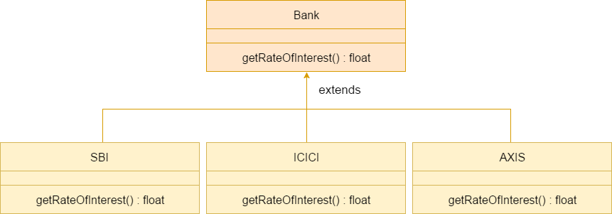

1. Implement following diagram. Explain aggregation.

